**Let’s Work Together for a Better Highway 252/I-94**

*Join the online conversation!*

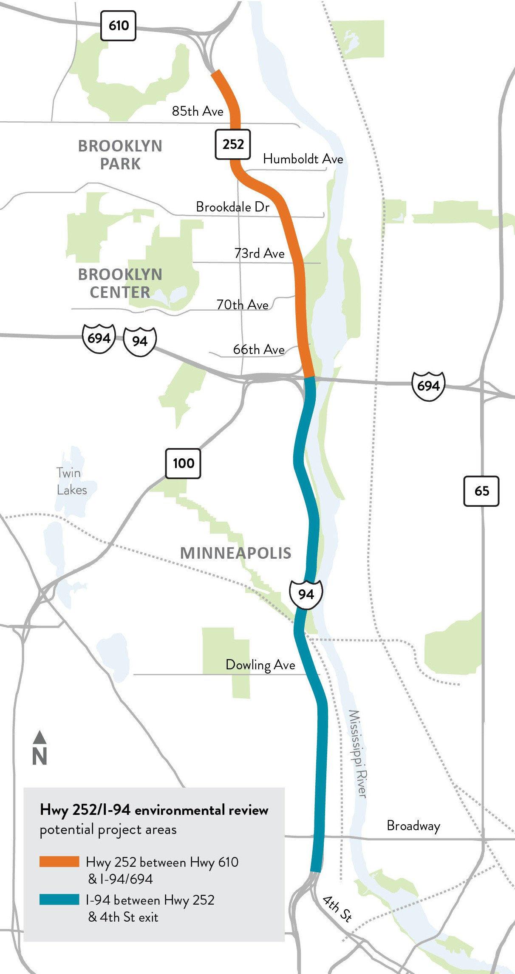



**Join one of the upcoming city-specific community conversations regarding improving the Hwy 252 and I-94 corridor.** At these conversations you will learn more about the potential project elements under consideration and provide your input on other elements that the project team should consider.

**Hwy 252 and I-94 in Brooklyn Center, Brooklyn Park and north Minneapolis are in need of improvements and repairs.**

Currently, both highways experience a high number of crashes, traffic congestion, and significant barriers for pedestrians

and bicyclists in the area. Both roads also are deteriorating and need to be repaired. MnDOT, along with local and federal project partners, are currently studying ways to address these issues on Hwy 252 between Hwy 610 in Brooklyn Park and

I-694 in Brooklyn Center and on I-94 from I-694 in Brooklyn Center to 4th St. N. in Minneapolis.

Focus area - **North Minneapolis:**

Tuesday, June 15 from 5 to 7 p.m.

Focus area - **Brooklyn Center**: Thursday, June 17 from 5 to 7 p.m.

Focus area - **Brooklyn Park**: Tuesday, June 22 from 5 to 7 p.m.

**How to Join**

**Visit tiny.cc/252EIS** to access the virtual open house

# Federal, state, and local partners are studying Hwy 252 and I-94 for needed improvements

Highway 252 and I-94 in Brooklyn Center, Brooklyn Park and north Minneapolis need improvements and repairs. MnDOT and local and federal partners are currently studying the Highway 252/I-94 corridor in these cities to lessen congestion and improve safety. As part of this effort, MnDOT will prepare an environmental impact statement, or EIS, that outlines the impact a potential construction project could have on the surrounding area.

# MnDOT and its partners continue to provide opportunities for public participation

The project team completed the first wave of public engagement for the EIS process. Thank you to those that watched the Project History and Overview and the Environmental Impact Statement Process videos and attended the Virtual Listening Session. Our next wave is underway. There is more information below on how to stay involved.

# The areas under study are:

* Hwy 252 between Hwy 610 in Brooklyn Park and I-94/I-694 in Brooklyn Center
* I-94 between I-94/I-694 in Brooklyn Center and North 4th Street and North 3rd Street entrance and exit ramps to and from Downtown Minneapolis.

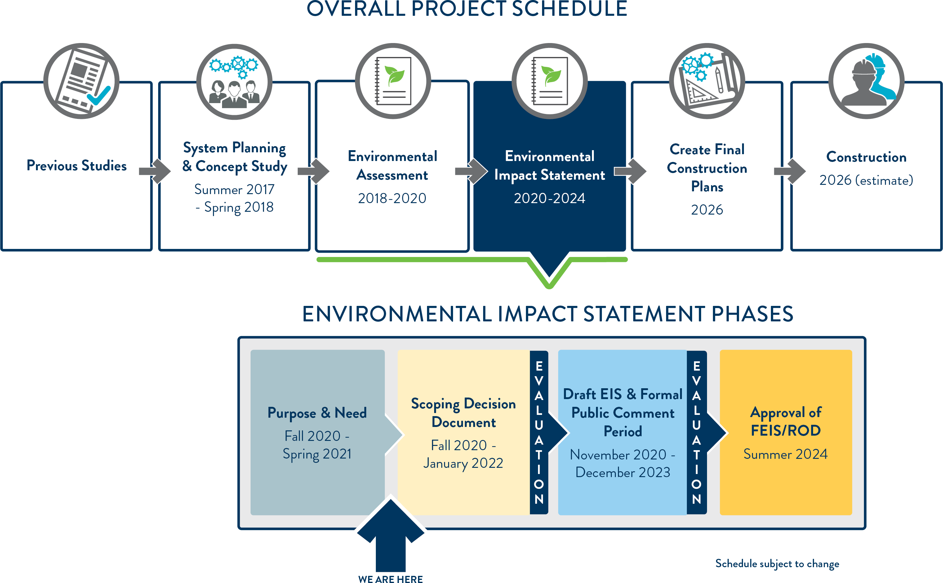

**For more information** Visit the project website at dot.state.mn.us/metro/projects/hwy252study/index.html

